## 1. Complete the sentences about advice with a verb from the table. Use each verb once. Use either should or ought to, as specified in parentheses:

|  |  |  |  |
| --- | --- | --- | --- |
| be | describe | do | retire |
| take | go out | spend | leave |
| find | meet | request | ~~listen~~ |

|  |  |  |
| --- | --- | --- |
| a. |  | Should we listen to the man’s advice? (we / should) |
| b. |  | We ought to take         a spare towel to the beach just in case. (we / ought to) |
| c. |  | The mayor shouldn’t spend too much of the city’s money. (the mayor / should / not) |
| d. |  | You ought to describe   what the man looked like. (you / ought to) |
| e. |  | If you don’t understand,      you should request         help. (you / should) |
| f. |  | Should we meet          again to discuss this some more? (we / should) |
| g. |  | The parents of the bad student ought to be           concerned. (the parents of the bad student / ought to) |
| h. |  | I shouldn’t go out         tonight. I have too much homework to do. (I / should / not) |
| i. |  | The man is so old.         He ought to retire           . (He / ought to) |
| j. |  | What time           we should leave         ? Jack wants to arrive at 10 AM. (we / should) |
| k. |  | What          should we do           on Sunday? We’re both free all day. (we / should) |
| l. |  | Michelle ought to find          a new boyfriend. I really dislike Paul. (Michelle / ought to) |

## 2. Complete the sentences with the correct forms of should, shouldn’t, had better, or had better not:

|  |  |  |
| --- | --- | --- |
| a. | This cake is delicious. You should try it. |  |
| b. | The movie starts in fifteen minutes. We        should             hurry. |  |
| c. | I didn’t bring an umbrella. It           had better not          be raining. |  |
| d. | You can borrow my phone but you          had better not           drop it. |  |
| e. | We           should          visit France one day. |  |
| f. | You         should             read this novel. It was pretty good. |  |
| g. | I          had better           take a photo of the whiteboard in case I forget what the teacher said. |  |
| h. | You          shouldn’t            take that elevator. It always breaks down. |  |
| i. | Chris          shouldn’t            feel bad about his performance. I thought it was really good. |  |
| j. | We           had better          bring some water with us. I’m not sure there is anywhere to buy a drink near the beach and it’s pretty hot today. |  |
| k. | Should            I call you later? |  |
| l. | If you’re planning to go to that restaurant on Friday evening, you         had better            make a reservation. It’s a pretty popular place. |  |

## 3. Read the situations and write sentences with had better (not):

|  |
| --- |
|  |
| a. Your friend, Jessica called you two days ago and left a message. You haven’t called her back. You are worried that she might get angry if you don’t call her back soon. You say to yourself… |
| I had better call Jessica. |

|  |
| --- |
|  |
| b. You are going hiking with a friend. You will probably be gone all day. There will be nothing to eat where you’re going. You are worried that if you don’t take anything to eat, you will get very hungry. You say to yourself… |
| I          had better take something to eat          . |

|  |
| --- |
|  |
| c. You and your friend, Ian are going to a nightclub. You are not sure if you can pay for drinks inside the club with your credit card. You are worried that if you don’t have cash, you will not be able to buy any drinks. You say to Ian… |
| We           had better get some extra money with us        . |

|  |
| --- |
|  |
| d. You want to ask your mother an important question, but she has a headache and is lying down on the sofa. You are worried that if you ask her the question, it will bother her. You say to yourself... |
| I         had better not talk to my mom right now            . |

|  |
| --- |
|  |
| e. You’re in your friend’s car. He is driving fast. There are a lot of cars. You are worried that if he doesn’t slow down, he will get into an accident. You say to him... |
| You         had better slow down because there are to many cars           . |

|  |
| --- |
|  |
| f. Your coworker is very sick. You are worried that if she stays at work, her condition will get worse. You say to her... |
| You          had better go to your house to rest          . |

|  |
| --- |
|  |
| g. You are at a restaurant. Your friend is offering a bite of something very spicy. Spicy food occasionally gives you a stomachache. You say to your friend... |
| I          had better not eat that          . |

|  |
| --- |
|  |
| h. You are doing your laundry. You are not sure if it is safe to put your sweater in the dryer. You are worried that it will shrink (get very small) if you put it in the dryer. You say to yourself... |
| I          had better not make a mistake          . |

## 4. Comment on the following sentences using should have + past participle:

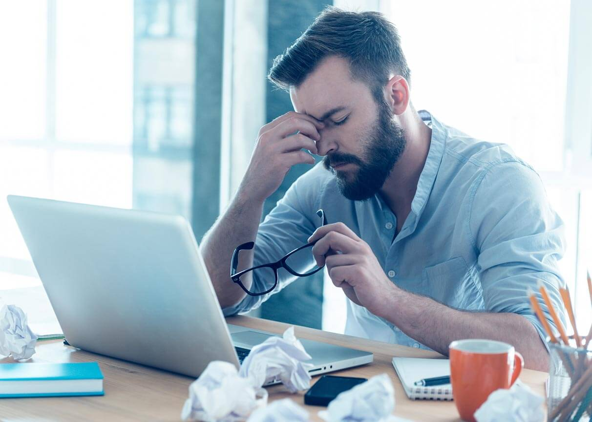

a. John decided to stay out late with his friends last night. Now, he’s having a hard time focusing at work.

He shouldn’t have gone out with his friends.



b. Yesterday, gas was cheaper than usual at the gas station but you didn’t buy any. Today, the price has gone up.

I should have filled my car yesterday with gas.

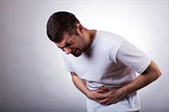

c. Steve ate two cheeseburgers and now his stomach is giving him pain.

I shouldn’t have eaten two burgers, I feel so bad.

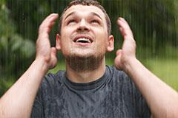

d. When you left home this morning, you decided to leave your umbrella at home. Now, it’s raining.

I should have brought an umbrella with me.

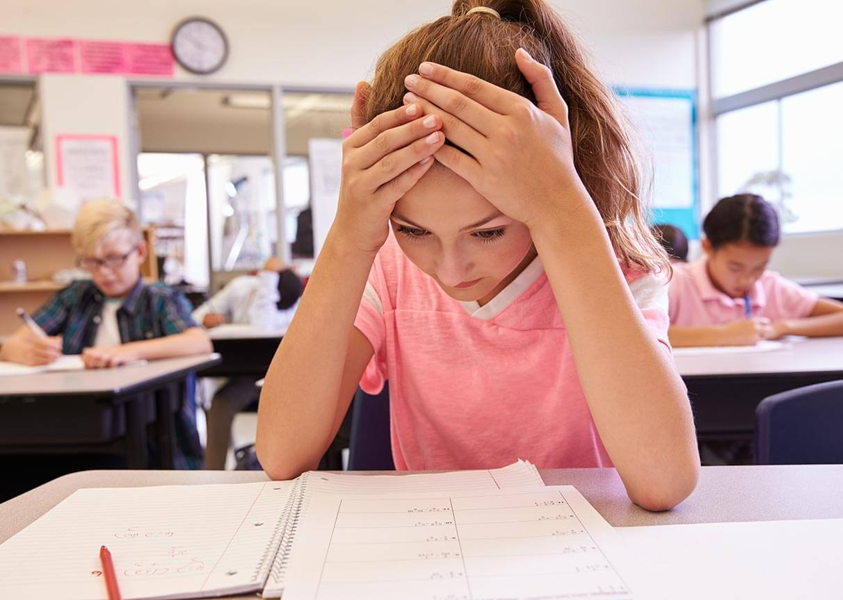

e. You didn’t study at all on the weekend and today, the teacher has decided to give the class a surprise test.

I should have studied, I’m getting into trouble for this.



f. John only left a 5% tip for the waitress. The waitress gave really good service.

You shouldn’t have left that much of tip for the waitress.

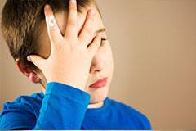

g. You ate some ice cream really quickly. Now you have a headache.

I shouldn’t have eaten the ice-cream that fast.



h. You gave a website your email address, and now you are receiving lots of junk mail.

I should have been careful with my email.



i. You lent your friend Jack some money two months ago. He still hasn’t paid you back.

I shouldn’t have lent money to my boyfriend.

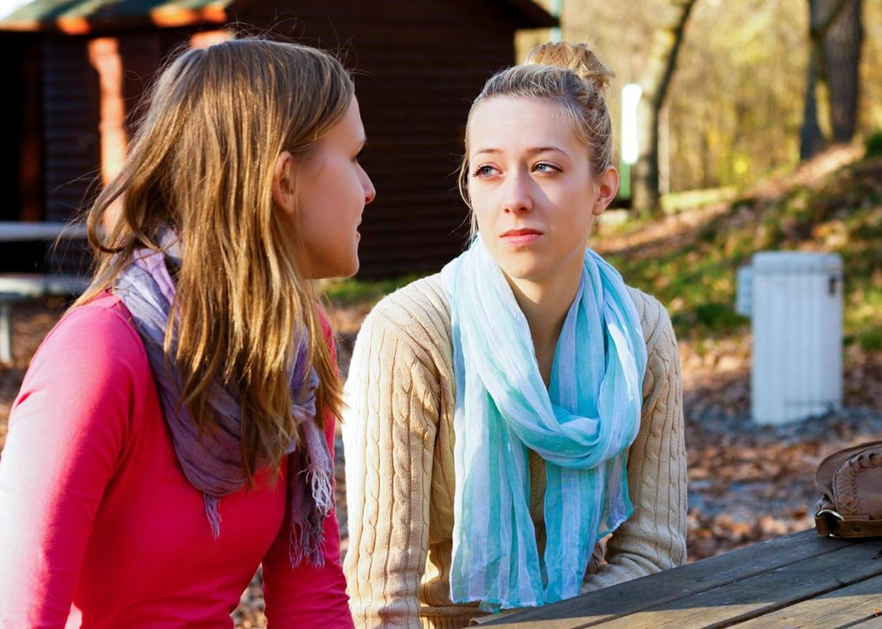

j. Jesse is at school. She leaves with her friend. Ten minutes later, they are walking in the park and Jesse says that she has to go to the bathroom.

You should have stay at school, is not okay to miss your classes.

## 5. Complete the conversations with your own words:

|  |  |
| --- | --- |
|  | |
| a. | “Hey the weather is going to be really nice this weekend. What shall we do?”  “Why don’t we go to the beach?”  “The beach? Sure! Good idea!” |

|  |  |
| --- | --- |
|  | |
| b. | “There is a new James Bond movie out. Would you like to see it with me?”  “Yeah! Let’s        go see it            .”  “Tonight? No, I’ve got plans for tonight. Why don’t       we go on Friday night           ?”  “Friday night. Sounds good. Shall           I drive         ?”  “No, I’ll drive. I’ll pick you up at 7 PM.”  “Okay. See you then.” |

|  |  |
| --- | --- |
|  | |
| c. | “What do you feel like for dinner tonight?”  “I don’t know. We could        eat pizza            .”  “Pizza? Again? Why don’t          we eat some tacos          ?”  “Okay. Shall I       get a reservation              ?”  “Yes, please. Make it for 8 PM if you can.”  “Okay, I’ll try.” |

|  |  |
| --- | --- |
|  | |
| d. | “Do you want to go shopping with me this afternoon?”  “Sure, but let’s          go           to Metrotown again. I don’t like that mall.”  “Okay, then where should        we go          ?”  “Why don’t       we go            to Robson Street? There are lots of good shops there.”  “Sure. Good idea.” |

|  |  |
| --- | --- |
|  | |
| e. | “Do you have any suggestions for a place to go on my vacation? I always go to Hawaii but I’d like to try somewhere new this time.”  “Why don’t        we go to Thailand             ?”  “Thailand would be cool, but it’s pretty far. That means it would be a little expensive to get there.”  “You could      have so much fun in there          .”  “Yeah, actually, I’ve never been there. I’ve heard good things.” |

|  |  |
| --- | --- |
|  | |
| f. | “I need a new book. I finished my last one a couple days ago.”  “You should          read Quiet by Susan Cain          . It’s my favourite book.”  “Really? Okay. Any other suggestions. What else should         I read           ?”  “Why don’t      you also read The Mist from    the author Stephen King? He has some pretty famous books.”  “Okay, I will. Thanks” |